**COURSE STRUCTURE**

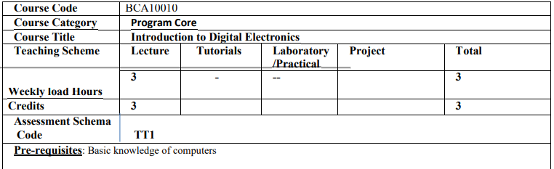**Course Objectives:**

1. To get familiar with concepts of digital electronics

2. To learn number systems and their representation

3. To understand basic logic gates, Boolean algebra and K-maps

4. To study arithmetic circuits, combinational circuits and sequential circuits

**Course Outcomes:**

1. Understand the number system used in digital electronics.

2. Realize and simplify Boolean Algebraic assignments for designing digital circuits using KMAP

3. Design and implement Combinational digital circuits as per the specifications

4. Design and implement Sequential digital circuits as per the specifications

**Course Contents:**

**Unit-I Number Systems and Binary Arithmetic [8]**

Introduction to Decimal, Binary, Octal and Hexadecimal number systems and their inter-conversions, Signed and fractional binary number representations, Binary Coded Decimal, Gray Codes, Gray to Binary and Binary to Gray conversion, Alphanumeric representation in ASCII codes. Rules of binary addition and subtraction, and subtraction using 1’s and 2’s complements

**Unit-II Logic gates and Boolean algebra [15]**

Logic gates (NOT, AND, OR, NAND, NOR XOR, XNOR gate) with their symbol, Boolean equation and truth table. Rules and laws of Boolean algebra, De Morgan’s theorem, simplification of Logic equations using Boolean algebra rules, Min terms, Max terms, Boolean expression in SOP and POS form, Introduction to Karnaugh Map, problems based on SOP (up to 4 variables), digital designing using K Map for: Gray to Binary and Binary to Gray conversion (3 bit)

**Unit-III Combinational Circuits [10]**

Half adder, Full adder, half subtractor, Parallel adder, study of Multiplexer (4:1) and Demultiplexer (1:4), Encoder (Decimal to BCD encoder and 3-bit priority encoder), Decoder (3to8 line decoder using gates only).

**Unit-IV Sequential circuits Design [12]**

Difference between combinational and Sequential circuits, RS Flip-Flop using NAND gate, D Flip Flop, J K Flip, T Flip Flop, Types of Shift Register, Counters: Types of Counters, Concept of Excitation Table,

Designing of 3-bit synchronous counter. Designing of Random sequence generator.

**Learning Resources:**

**Textbooks:**

1. Digital Design, M. Morris Mano, “3rd Edition, PHI, New Delhi.

2. Digital Systems-Principles and Applications, Ronald J. Tocci., 6/e. PHI. New Delhi. 1999.

3. Digital electronics, G. K. Kharate-Oxford university press

4. Digital circuits and design, S.Salivahana & S.Arivazhagan - Digital circuits and design

**Reference Books:**

1. Digital Fundamentals: Floyd T.M., Jain R.P., Pearson Education, 5th Edition.

2. Digital Electronics: Jain R.P., Tata McGraw Hill, 3rd Edition.

3. Digital Principles and Applications: Malvino Leach, Tata McGraw-Hill, 2nd Edition.

**Pedagogy:**

Participative learning,

discussions,

problem solving,

assignments,

Tutorials,